Practice Exercise 1

**1) Create a table name STUDENT with following structure.**

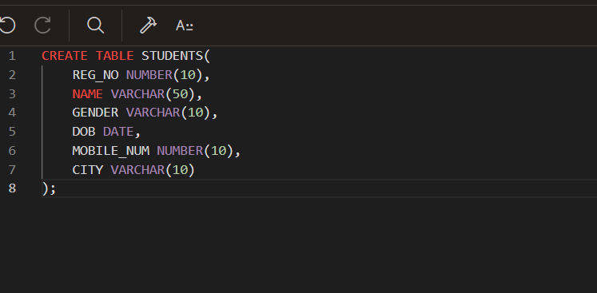

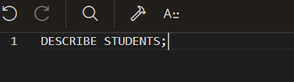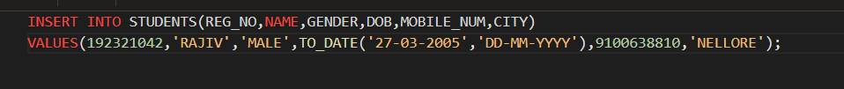



**2) Create a table name FACULTY with following structure.**

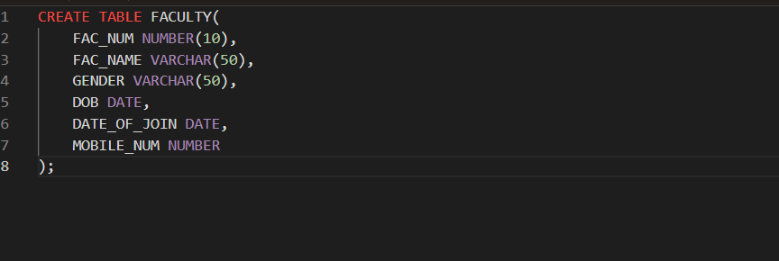

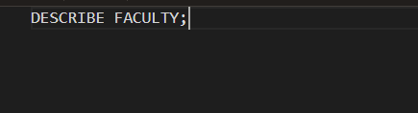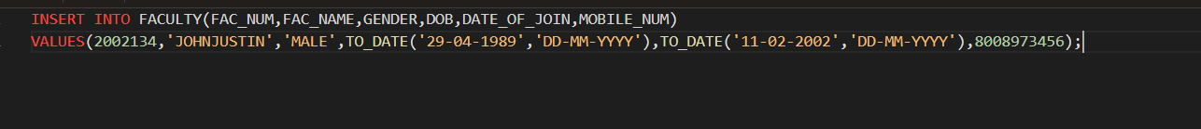

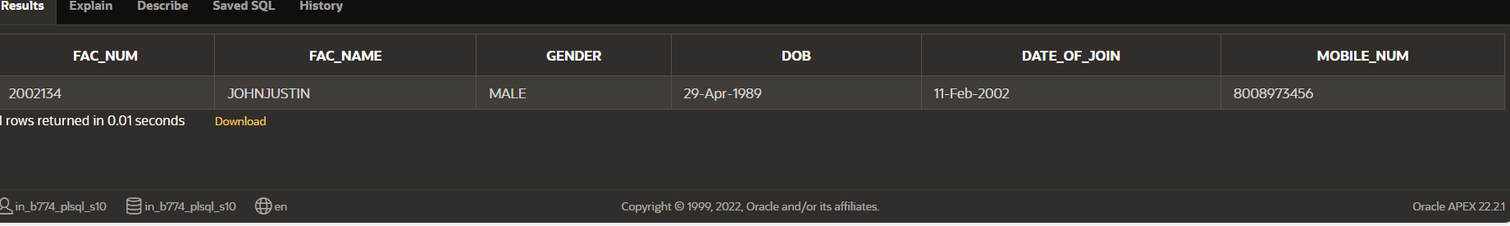

**3) Create a table name DEPARTMENT with following structure.**

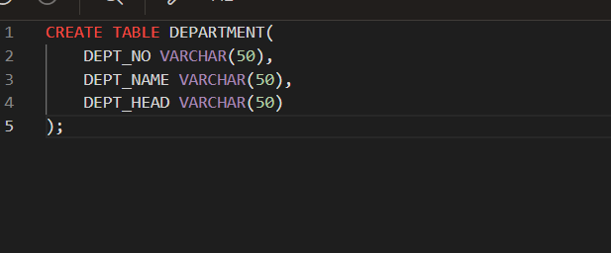

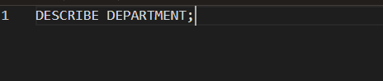

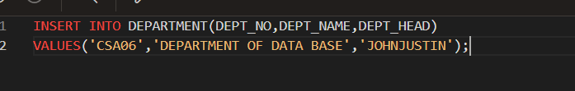

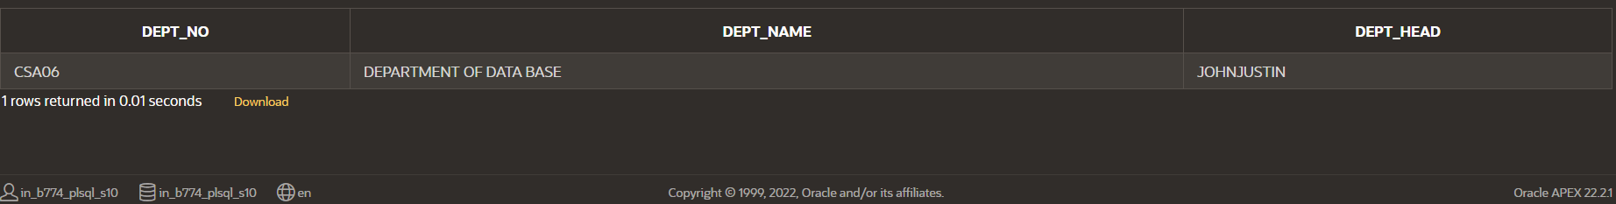

**4) Create a table name COURSE with following structure.**

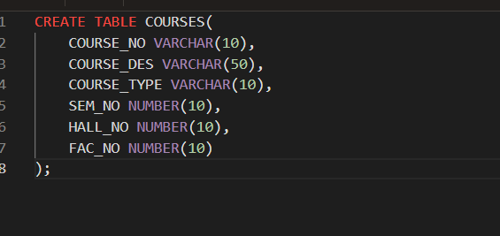

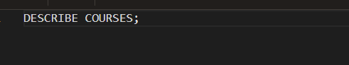

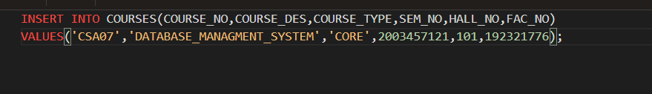

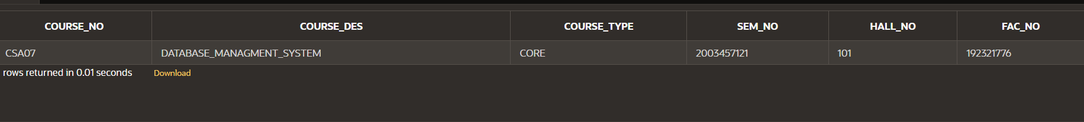

**5) Modify the table FACULTY by adding a column name DeptNo**

**of datatype VARCHAR(4)**





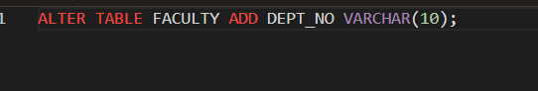

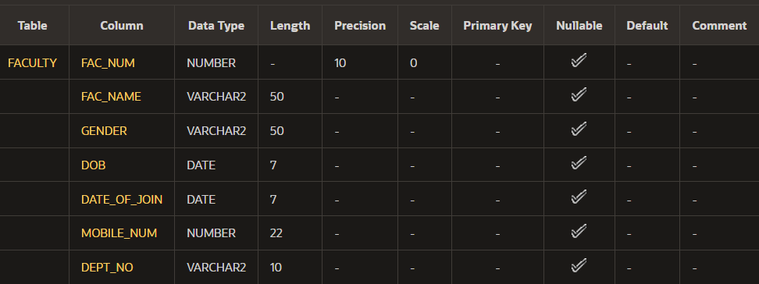

**6) Alter the table STUDENT with following structure.**

**Column Constraints # Name**

**PRIMARY**

**1 RegNo KEY**

**2 MobileNo NOT NULL**

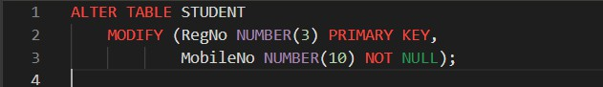

**7)Alter the table name FACULTY with following structure. The DeptNo in this table refers the DeptNo in the DEPARTMENT table.**

Column Constraints # Name

FacNo

PRIMARY 1 KEY

Gender CHECK

2 ‘M’ or ‘F’

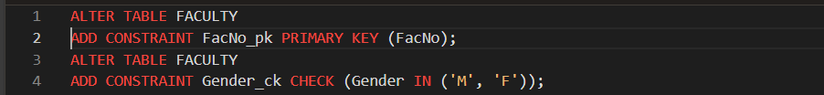

**8)After the FACULTY table is successfully created, test if you can add a constraint FOREIGN KEY to the DeptNo of this table.**

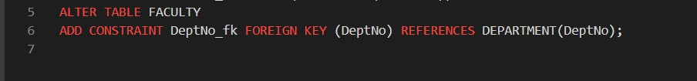

**9)Alter the table name DEPARTMENT with following structure.**

Column Constraint # Name

DeptNo PRIMARY 1 KEY



**10) Alter the table name COURSE with following structure.**

Column Constraint # Name

CourseNo PRIMARY

1. **KEY**
2. **SemNo 1 to 6**

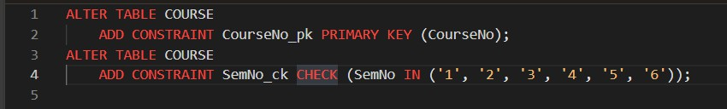

Practice Questions:

1. **Populate all the five tables with your own data.**

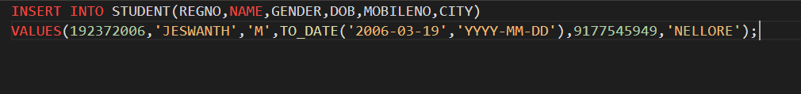



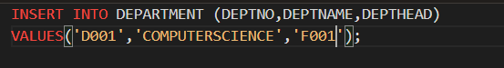





**12.Update the value of student name whose register number is ‘19232006’.**

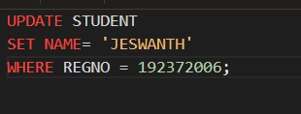

**13.Delete the record in the table FACULTY, who resigned her job.**

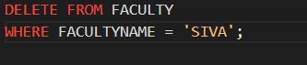

**14.Modify the date of birth for the faculty whose name is RAM; with a value ‘1983-05-01’.**

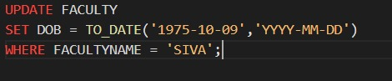

**15.Remove all faculty who are having over 65 years.**

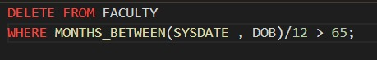

**16.View all the records from the five tables.**

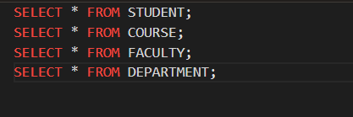

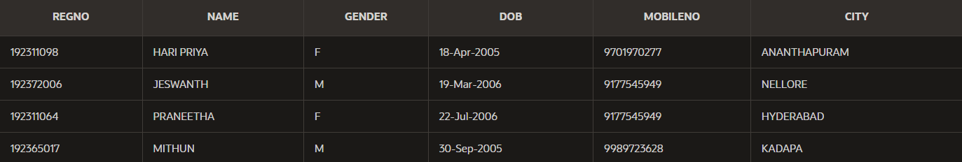

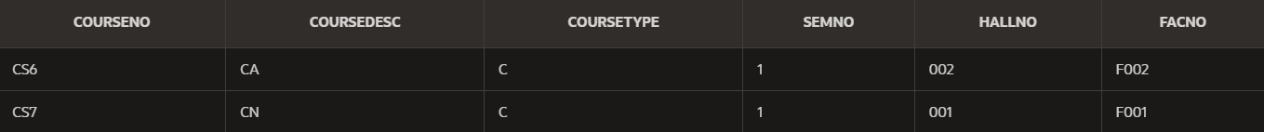



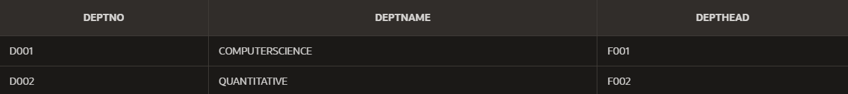

WHERE Clause Questions::

**17.The student counsellor wanted to display the registration number, student name and date of birth for all the students.**

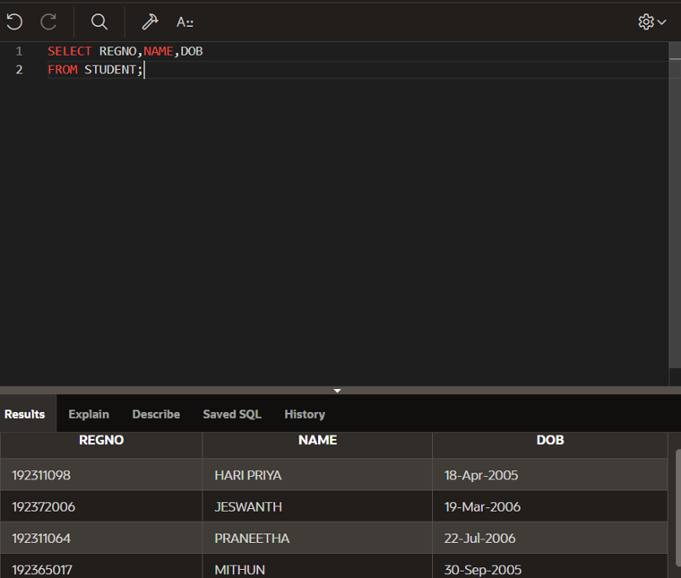

**18.The controller of examinations wanted to list all the female students.**

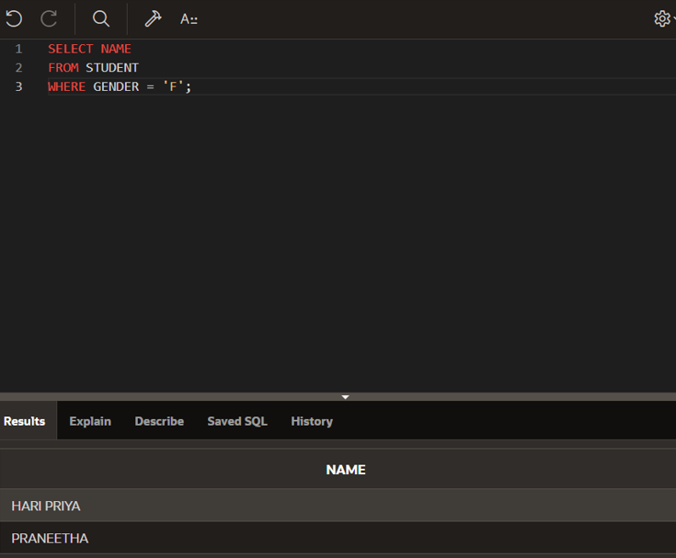

1. **Display all faculty details joined before “November 2024”.**

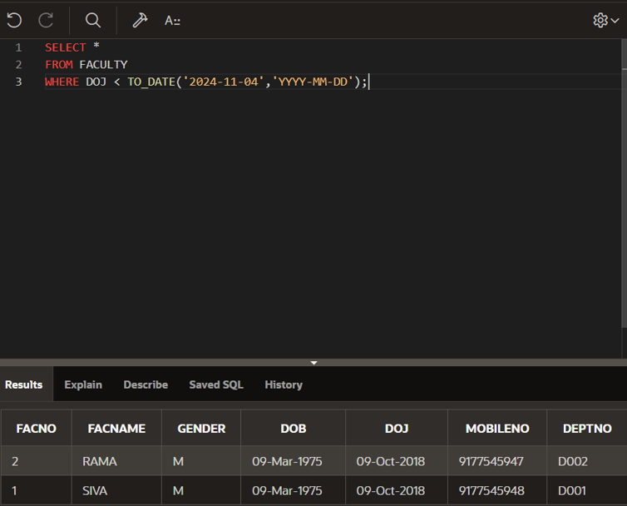

1. **Display all the courses not allotted to halls**

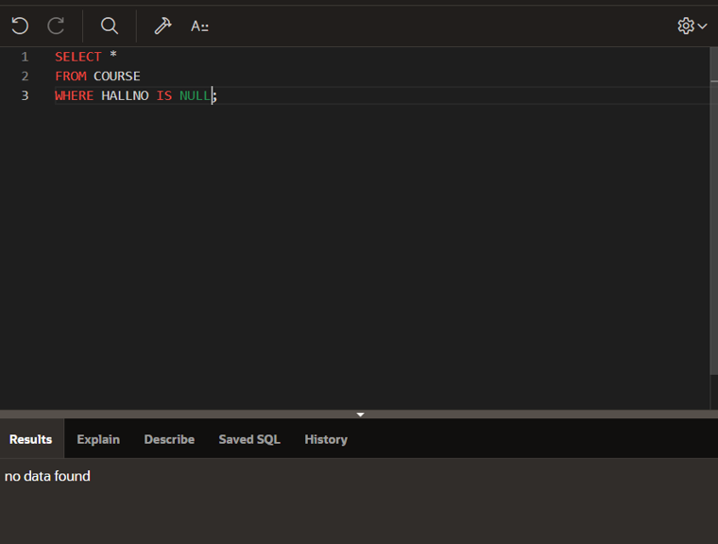

LIKE Clause Questions::

1. **List the students whose name ends with the substring “a”**

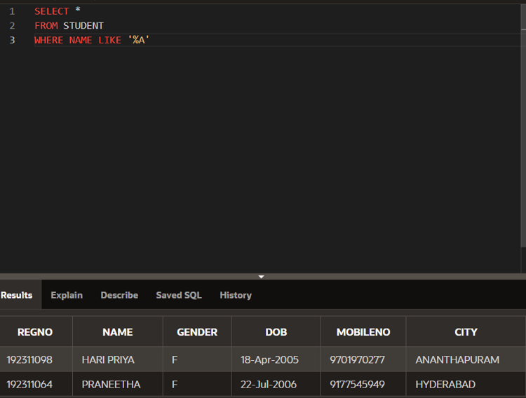

1. **Display all students whose name contains the substring “Ha”**

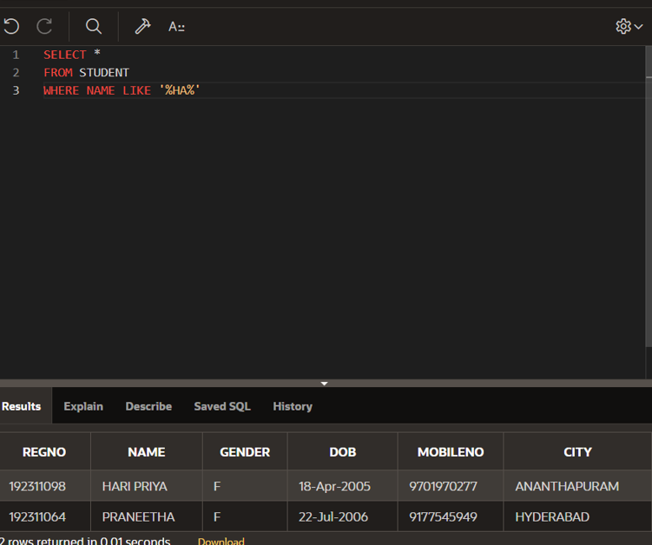

1. **Find all the students who are located in cities having “NEL” as substring**

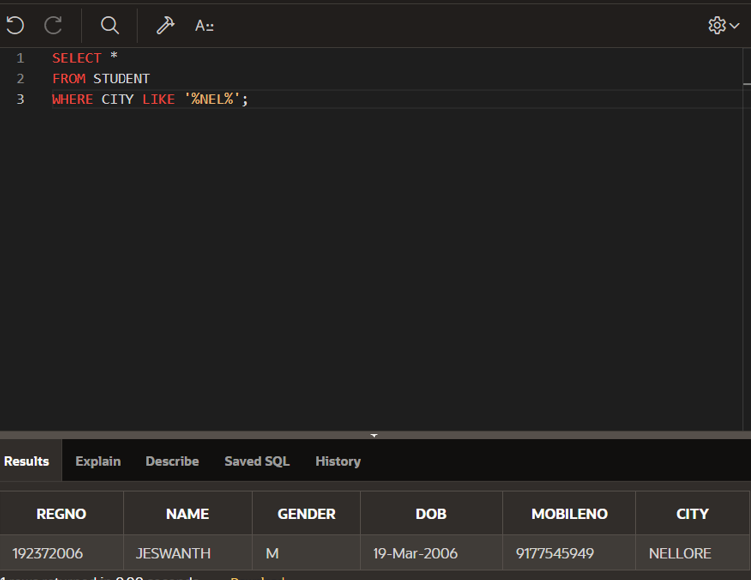

1. **Display the students whose names do not contain six letters.**

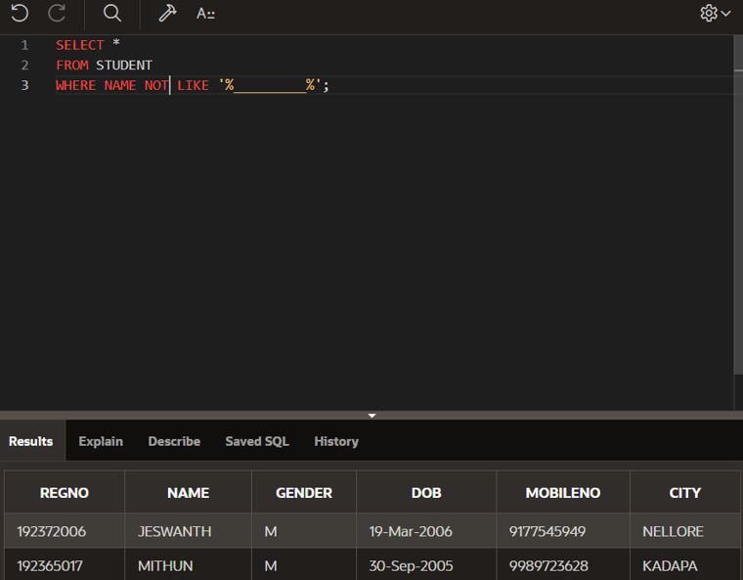

1. **Find all the students whose names contains “th”**

